leeds beckett university

system developement

howie’s performance car hire

sulabh shrestha

77171780

## Contents

IN THIS SECTION:

Part-A: Current System

* A Physical Level 1 DFD of existing system
* UML Use Case

Part-B: Required System

* A Logical Level 1 DFD of the proposed new system
* A requirements catalogue for the new system
* A List of entities and their attributes needed for the new system

A Physical Level 1 DFD of the existing system

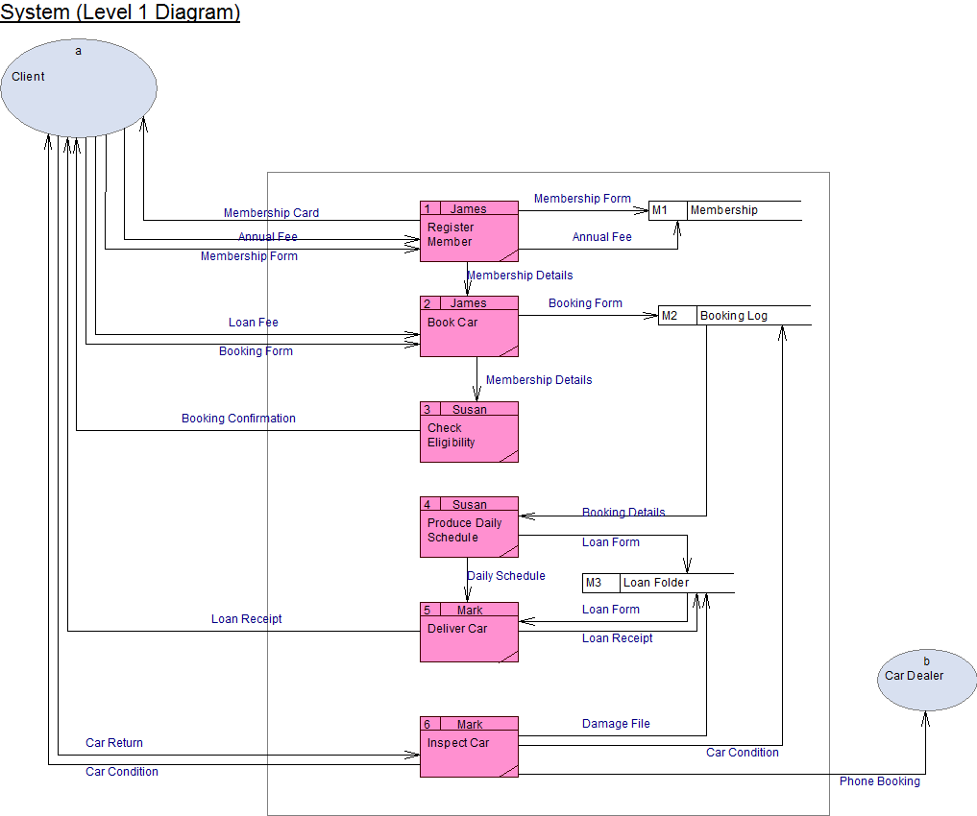

A UML Use Case Diagram comprising of all first level base use-cases.

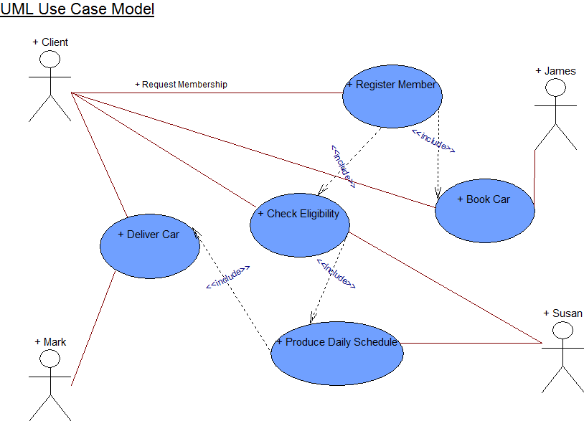

A Logical Level 1 DFD of the new proposed new system

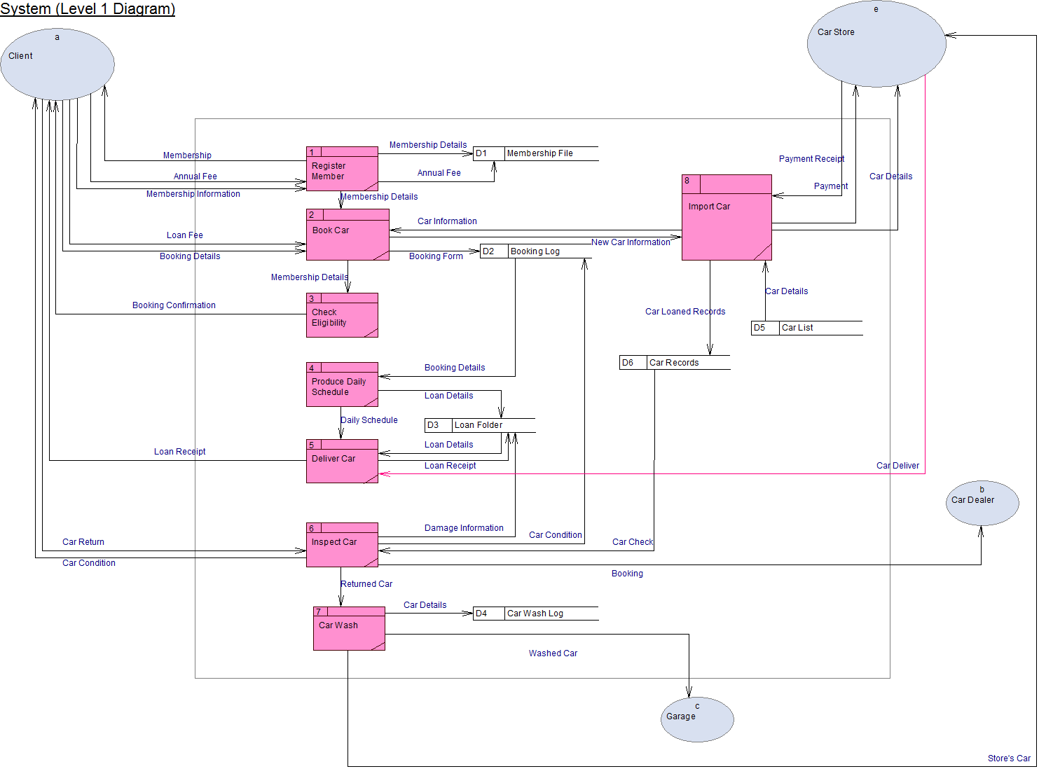

A requirements catalogue for the new system

|  |  |
| --- | --- |
| **Requirements Catalogue Entry** | |
| Requirement Number | 1 |
| Requirement Name | Online Booking |
| Description | Provides information related to car hiring like estimated delivery dates, return deadlines. This online booking is based on real time. |
| Priority | Essential |
| Source | Web Developer |
| Owner | Howard |
| Issues and outstanding questions | Possibility of system hack, phishing, stealing information. |
| Comments/Suggested Solutions | Must hire a professional skilled computer technician to cover all the possibilities of hack. |
| Benefits | Helps to reduce time. |
| Related Documents | Booking Log, Membership |
| Related Requirements | None |
| Resolution | None |

|  |  |
| --- | --- |
| **Requirements Catalogue Entry** | |
| Requirement Number | 2 |
| Requirement Name | Car Wash |
| Description | Washes the sent cars if they are returned in an unclean condition. |
| Priority | Essential |
| Source | Mark |
| Owner | Howard |
| Issues and outstanding questions | Repeated Car Wash may be damaging |
| Comments/Suggested Solutions | Make sure that the interior of the car is also cleaned |
| Benefits | The car would look attractive and sanitation is maintained |
| Related Documents | Car Wash Log |
| Related Requirements | None |
| Resolution | None |

|  |  |
| --- | --- |
| **Requirements Catalogue Entry** | |
| Requirement Number | 3 |
| Requirement Name | Database Backup |
| Description | A backup into a cloud based system/server. |
| Priority | Essential |
| Source | James |
| Owner | Howard |
| Issues and outstanding questions | Requires repeated syncing and constant connection to the internet with the server fees. |
| Comments/Suggested Solutions | Make sure that data is scheduled to sync at certain points. |
| Benefits | Would ensure that data remains safe and intact even in the incidence of loss of data in the primary office. |
| Related Documents | Booking Log, Membership Log, Loan Folder |
| Related Requirements | None |
| Resolution | None |

|  |  |
| --- | --- |
| **Requirements Catalogue Entry** | |
| Requirement Number | 4 |
| Requirement Name | Driver |
| Description | Driver drives the vehicle if hired by the customer |
| Priority | Essential |
| Source | Mark |
| Owner | Howard |
| Issues and outstanding questions | Driver may be drunk |
| Comments/Suggested Solutions | Alcohol to be strictly Prohibited |
| Benefits | Extra profit can be earned by commissioning drivers |
| Related Documents | Driver Log |
| Related Requirements | None |
| Resolution | None |

|  |  |
| --- | --- |
| **Requirements Catalogue Entry** | |
| Requirement Number | 5 |
| Requirement Name | IT Department |
| Description | Regulates the technological devices |
| Priority | Essential |
| Source | James |
| Owner | Howard |
| Issues and outstanding questions | Electronics might malfunction |
| Comments/Suggested Solutions | Regular testing and repair |
| Benefits | Helps to update the Website, and troubleshoot and diagnose technical issues of the office any time. |
| Related Documents | System Log |
| Related Requirements | None |
| Resolution | None |

A list of entities and their attributes needed for the new system

1. Entity: Client

Attributes:

* Client Name
* Email Address
* Contact Number
* Credit Card Details
* Address
* Membership ID

1. Entity: Car Dealer

Attributes:

* Dealer Name
* Email Address
* Contact Number
* Dealer Website

1. Entity: Car Store

Attributes:

* Store Name
* Store Address
* Website
* Store Number

1. Entity: Garage

Attributes:

* Garage Name
* Garage Address
* Damage list
* Garage Equipment’s

1. Databases: Membership

Attributes:

* Membership ID
* Membership Details
* Membership Name
* Payment info
* Book car list
* Pending list

1. Databases: Booking Log

Attributes:

* Booking Date
* Booking List
* Booked Cars
* Delivery Date

1. Databases: Loan Folder

Attributes:

* Loan Details
* Loan Date
* Loaned Car

1. Databases: Car Records

Attributes:

* Car Company
* Car Name
* Car manufacturer date
* Car Model number

1. Databases: Car List

Attributes:

* Car Company
* Car Name
* Car manufacturer date
* Car Model number